Brookwood Math Team 8/28/2014

Problem 1

Problem 2



Problem 3

If [|x - 2| = p](http://www.artofproblemsolving.com/Forum/code.php?hash=7a63e4c1542e0134811c0407bad38dd8156cc4be&sid=c3e36beaec1ddc4109ce44a51b41a954), where [x < 2](http://www.artofproblemsolving.com/Forum/code.php?hash=e605439a7f380a0ed8e20eee137a4ca9e94d6d9d&sid=c3e36beaec1ddc4109ce44a51b41a954), then [x - p =](http://www.artofproblemsolving.com/Forum/code.php?hash=dc817081cbd3443a5906ad24af73d5f549df1447&sid=c3e36beaec1ddc4109ce44a51b41a954)

[\mathrm{(A) \ -2 } \qquad \mathrm{(B) \ 2 } \qquad \mathrm{(C) \ 2-2p } \qquad \mathrm{(D) \ 2p-2 } \qquad \mathrm{(E) \ |2p-...](http://www.artofproblemsolving.com/Forum/code.php?hash=5cbf6cbf4833dfcdd51a7a8466182e7bfb72df86&sid=c3e36beaec1ddc4109ce44a51b41a954)

Problem 4

The sides of a triangle with positive area have lengths [4](http://www.artofproblemsolving.com/Forum/code.php?hash=1b6453892473a467d07372d45eb05abc2031647a&sid=0dde1c8354afaafedfc9487bbbc33d88), [6](http://www.artofproblemsolving.com/Forum/code.php?hash=c1dfd96eea8cc2b62785275bca38ac261256e278&sid=0dde1c8354afaafedfc9487bbbc33d88), and [x](http://www.artofproblemsolving.com/Forum/code.php?hash=11f6ad8ec52a2984abaafd7c3b516503785c2072&sid=0dde1c8354afaafedfc9487bbbc33d88). The sides of a second triangle with positive area have lengths [4](http://www.artofproblemsolving.com/Forum/code.php?hash=1b6453892473a467d07372d45eb05abc2031647a&sid=0dde1c8354afaafedfc9487bbbc33d88), [6](http://www.artofproblemsolving.com/Forum/code.php?hash=c1dfd96eea8cc2b62785275bca38ac261256e278&sid=0dde1c8354afaafedfc9487bbbc33d88), and [y](http://www.artofproblemsolving.com/Forum/code.php?hash=95cb0bfd2977c761298d9624e4b4d4c72a39974a&sid=0dde1c8354afaafedfc9487bbbc33d88). What is the smallest positive number that is **not** a possible value of [|x-y|](http://www.artofproblemsolving.com/Forum/code.php?hash=d65bd376e83ad24c6218b7fd8ee3ca5514e183d2&sid=0dde1c8354afaafedfc9487bbbc33d88)?

[\mathrm{(A)}\ 2 \qquad\mathrm{(B)}\ 4 \qquad\mathrm{(C)}\ 6 \qquad\mathrm{(D)}\ 8 \qquad\mathrm{(E)}\ 10](http://www.artofproblemsolving.com/Forum/code.php?hash=177d14e41e3ac4a3d54ceab4297c4f1008e7c4b2&sid=0dde1c8354afaafedfc9487bbbc33d88)

Problem 5

Two different prime numbers between [4](http://www.artofproblemsolving.com/Forum/code.php?hash=1b6453892473a467d07372d45eb05abc2031647a&sid=0dde1c8354afaafedfc9487bbbc33d88)and [18](http://www.artofproblemsolving.com/Forum/code.php?hash=9e6a55b6b4563e652a23be9d623ca5055c356940&sid=0dde1c8354afaafedfc9487bbbc33d88)are chosen. When their sum is subtracted from their product, which of the following numbers could be obtained?

[\mathrm{(A)}\ 21 \qquad\mathrm{(B)}\ 60 \qquad\mathrm{(C)}\ 119 \qquad\mathrm{(D)}\ 180 \qquad\mathrm{(E)}\ 231](http://www.artofproblemsolving.com/Forum/code.php?hash=971f85055c4eaf00ad721c93256c74427a784807&sid=0dde1c8354afaafedfc9487bbbc33d88)

Problem 6

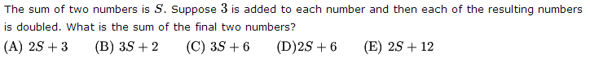

Problem 7

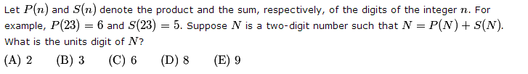

Problem 8

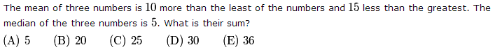

Problem 9

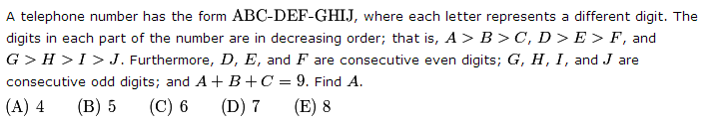

Problem 10

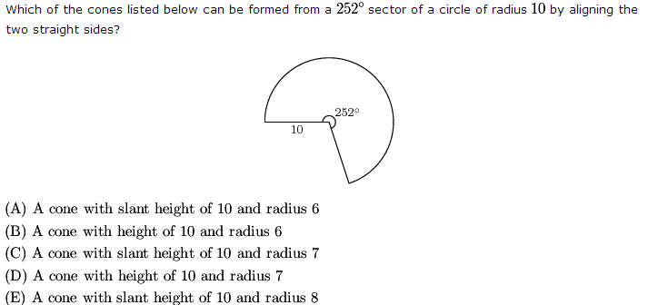

Problem 11

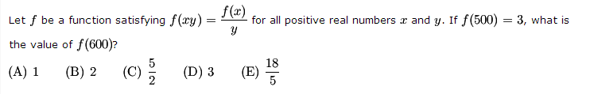

Problem 12

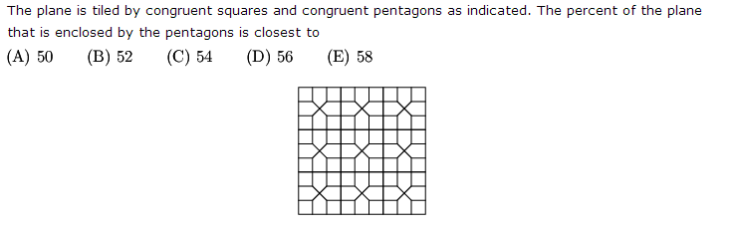

Problem 13

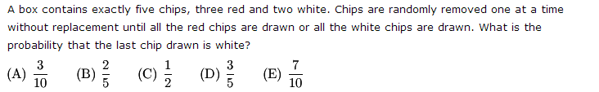

Problem 14

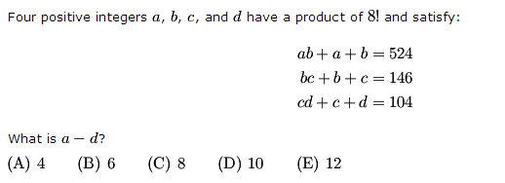

Problem 15

