Telescoping Sum – Partial Fractions
For example, the series
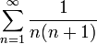
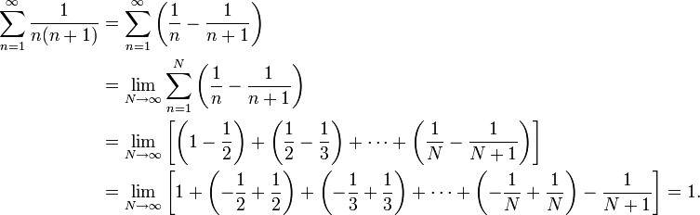simplifies as
Not all sums that can be split into partial fractions will cancel, however.
For example:
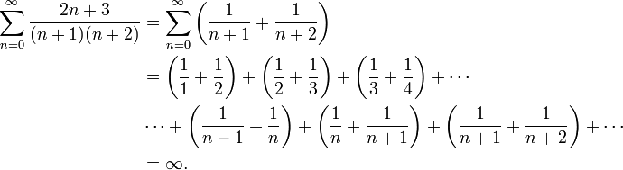
Challenge Problem:
Hint: Sum to Product Formula

Polynomials
Basic Ideas
- Remainders
  - When we divide f(x) by (x-a), the remainder is a
  - Given f(x) and given g(x), there exist unique p(x) and q(x) such that f(x)=p(x)g(x)+q(x)
- Roots
  - Rational Root Theorem: If f(p/q)=0, that is, p/q is a root where p and q are integers, then p must be divisible by the coefficient of the constant, and q must be divisible by the leading coefficient.
  - Vieta’s formulas: Given a polynomial of degree n,
The sum of the roots is equal to –a_{n-1}/a_{n}, the pairwise sum of the roots is equal to a_{n-2}/a_{n}, so on and so forth until the product of all the roots is equal to (-1)^{n} a_{0.}
Exercises

